***Experiment 6:***

**Operational Amplifiers and Their Applications**

Note::(Vcc of +12v and -12v should be given from the Power Supply's 3 terminal port, where the “COM / 0V” should be grounded.)

**1. Voltage follower:** Set up the voltage follower circuit (Voltage gain=1) as shown in fig 1 and carry out the following:

• Measure the output of signal generator directly on the DSO and adjust it to be 2V peak to peak.

• Connect 100Ω resistor across function generator and measure the output of the signal.

• Disconnect the 100Ω resistor and connect the signal generator output to the input of the circuit shown in fig 1 and measure the output. Comment on the observations.

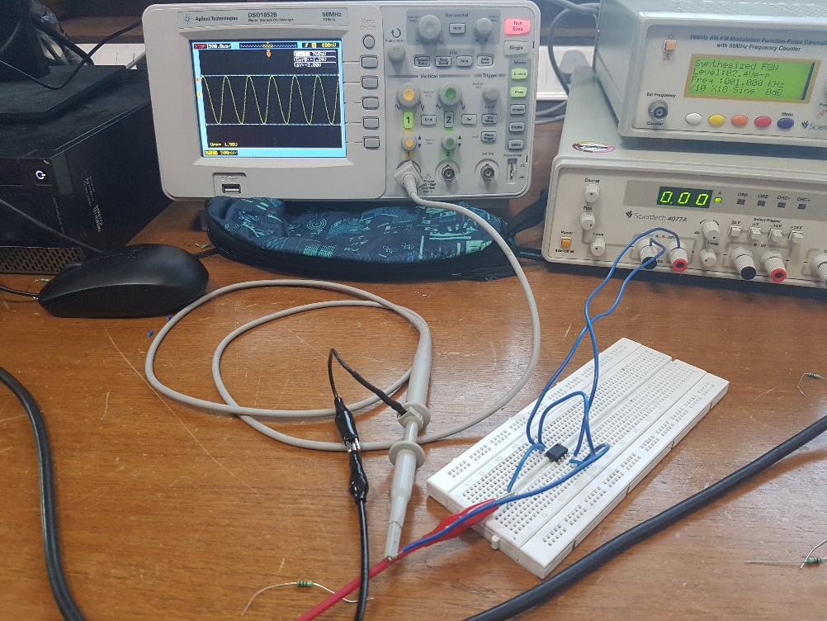

Snapshot of breadboard with circuit connected as in Fig.1 in manual

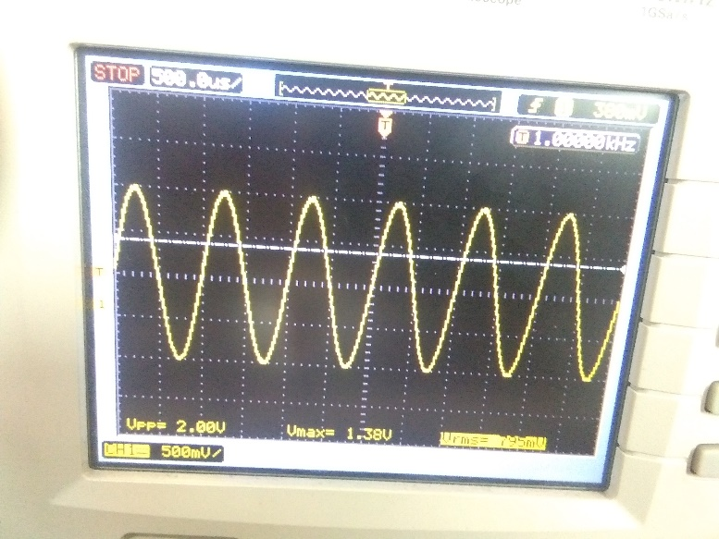

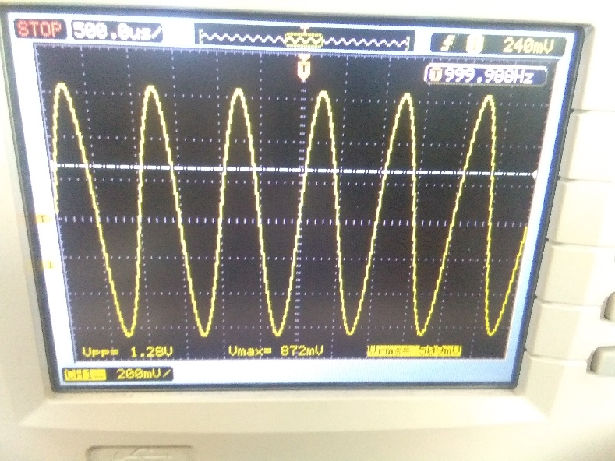.

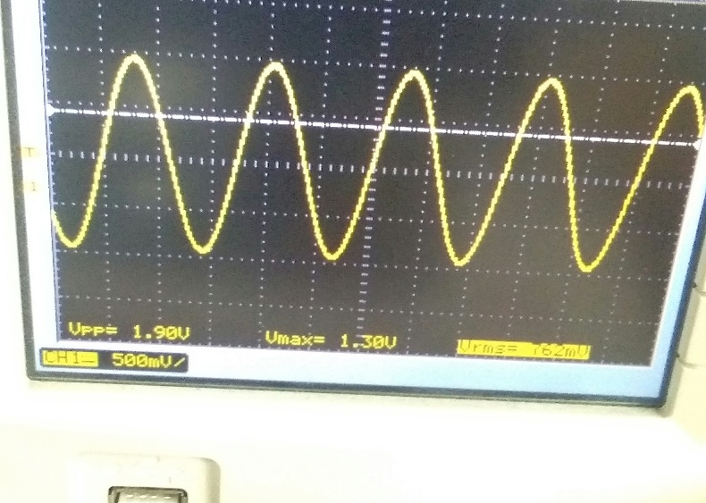

snapshots of the DSO screen with waveforms across the signal generator, 100 ohm resistor, and op-amp output

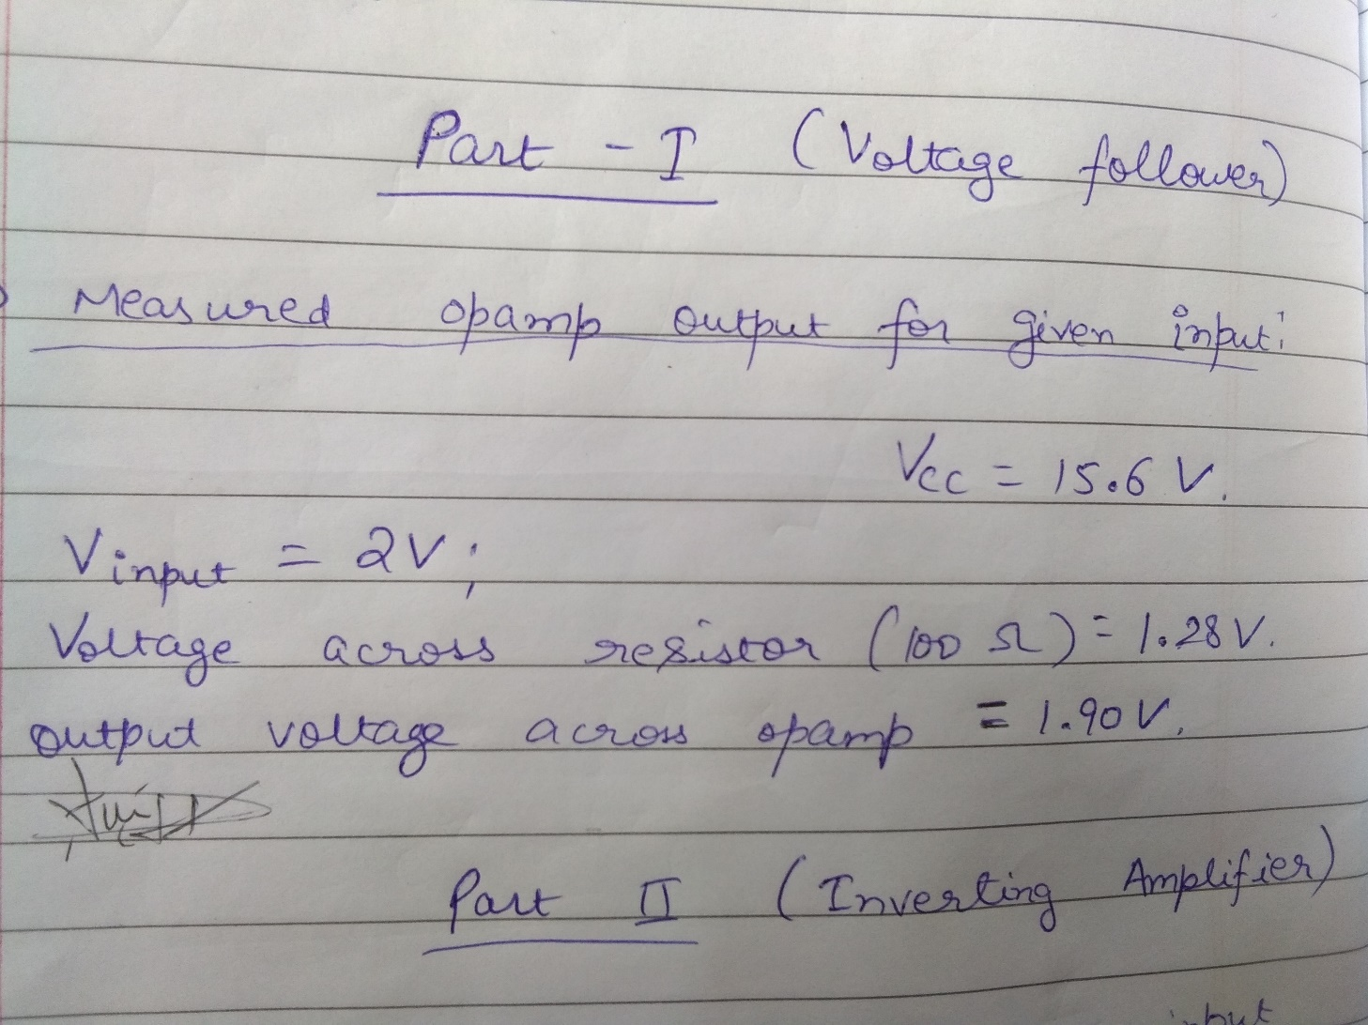

Measured op amp output for given input

**2. Inverting Amplifier**: Setup the circuit as shown in Fig 2. Choose resistances Rin equal to 1KΩ. Choose Rf equal to 10KΩ to achieve gain -10 and Rf equal to 47KΩ to achieve gain -47. Verify the operations at different frequencies, say 1 KHz and 40 KHz.

Does the gain depend upon the frequency of operation?

Voltage gain= - (Rf/Rin)

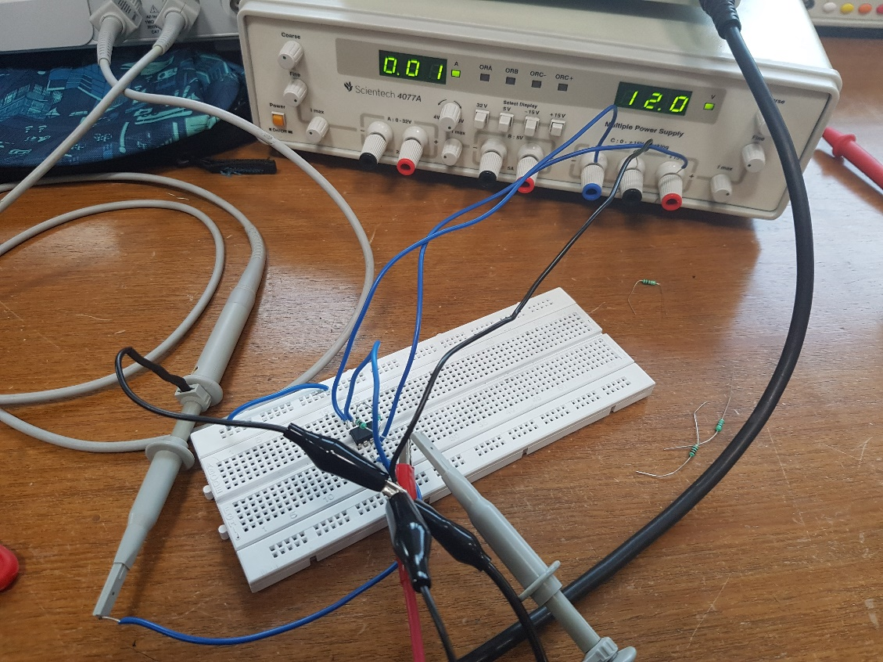

Snapshot of breadboard with components connected as per Fig. 2 in the manual

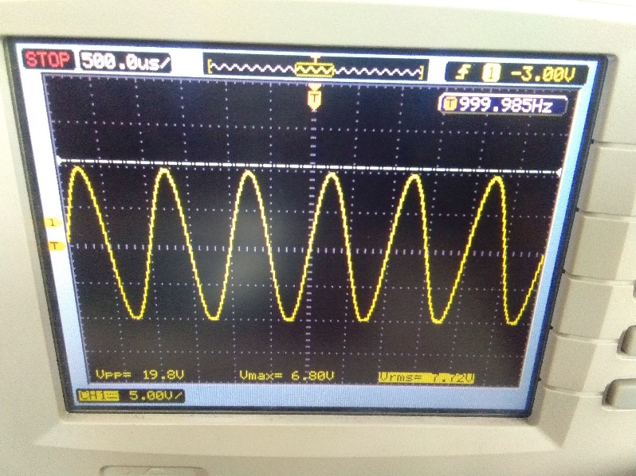

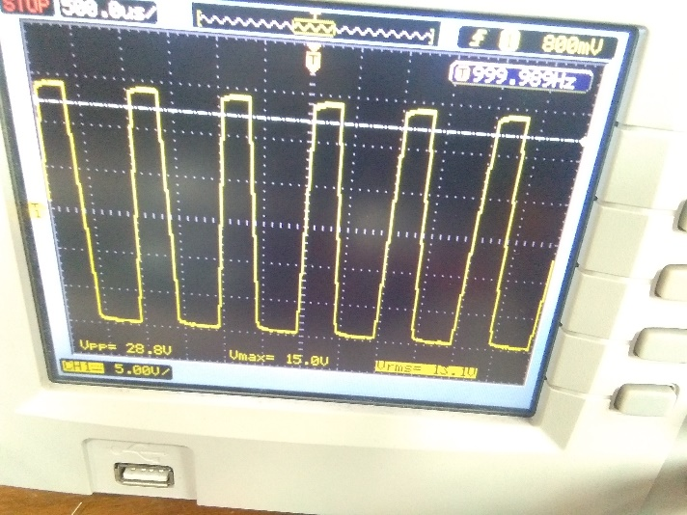

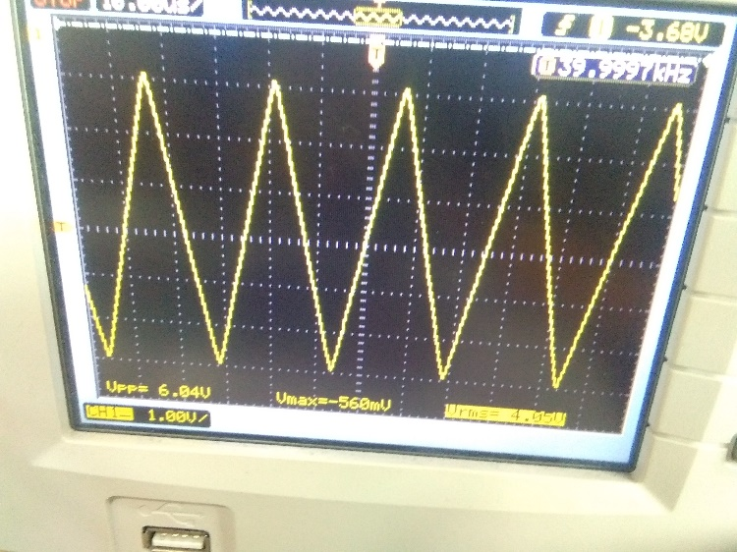

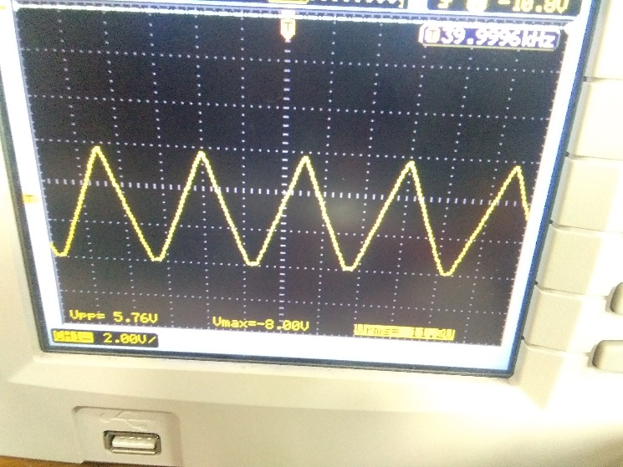

Snapshots of the DSO screen waveform across op amp output

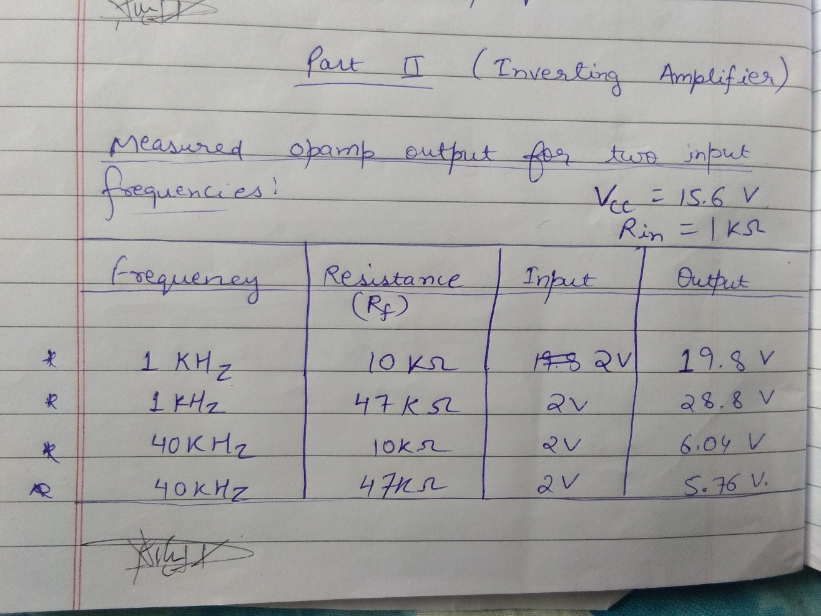

measured op amp output for two input frequencies

**3. Non-inverting Amplifier:** Setup the circuit as shown in fig 3. Choose resistance R1 equal to 1KΩ. Choose R2 equal to 10KΩ to achieve gain 11 and R2 equal to 47KΩ to achieve gain 48. Verify the operations at different frequencies.

Voltage gain= 1+ (R2/R1)

Note::For a given gain and a given Vcc, estimate the input voltage that can be applied without saturating the output. Verify this experimentally.

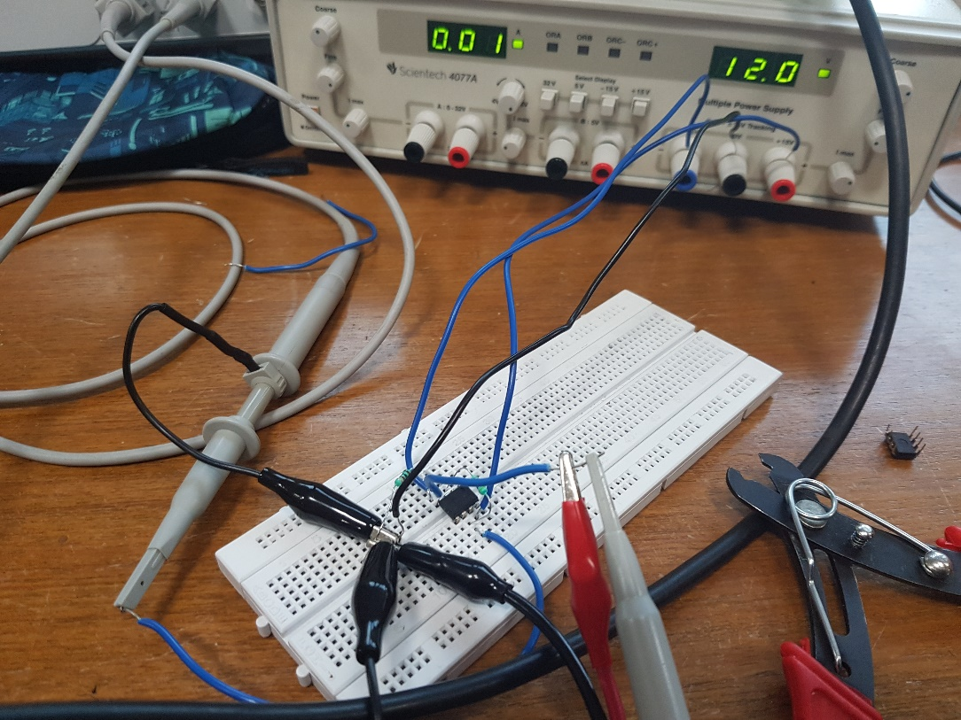

Snapshot of the breadboard with components connected as in Fig. 3 of the manual

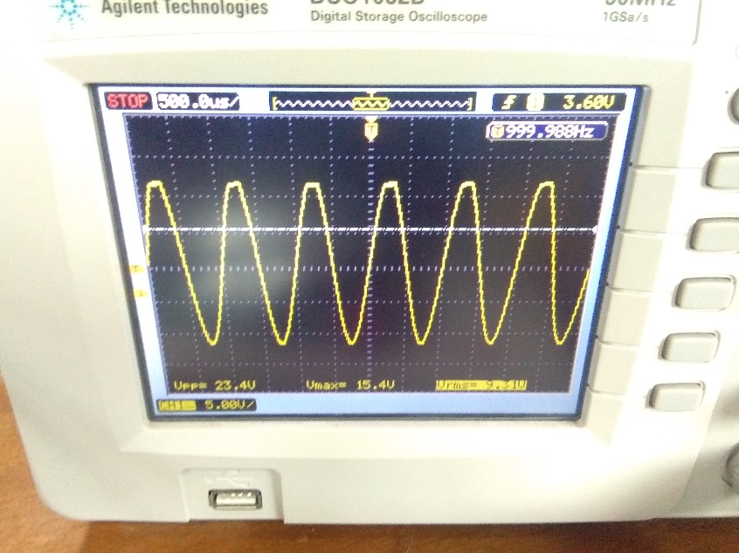

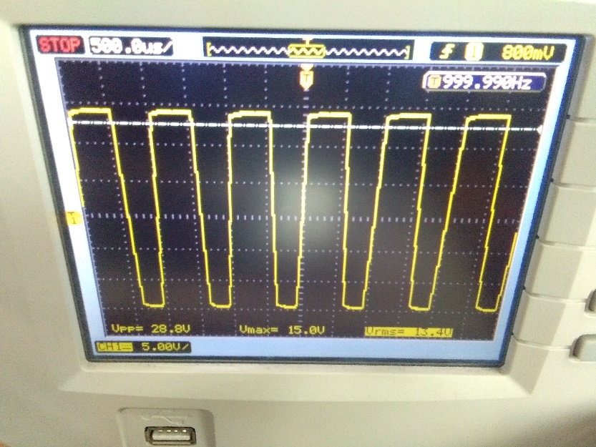

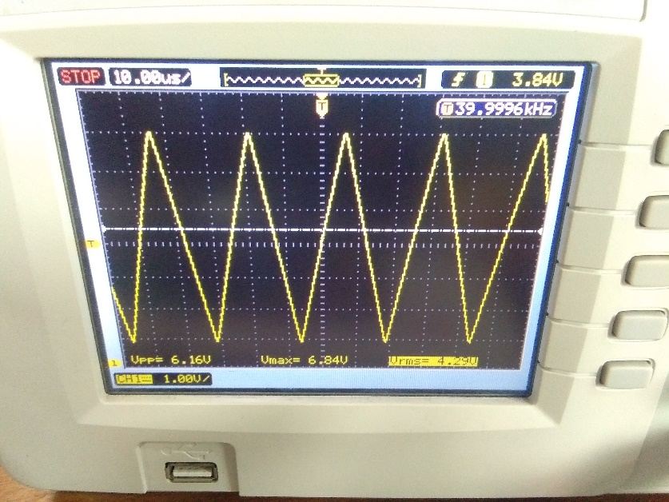

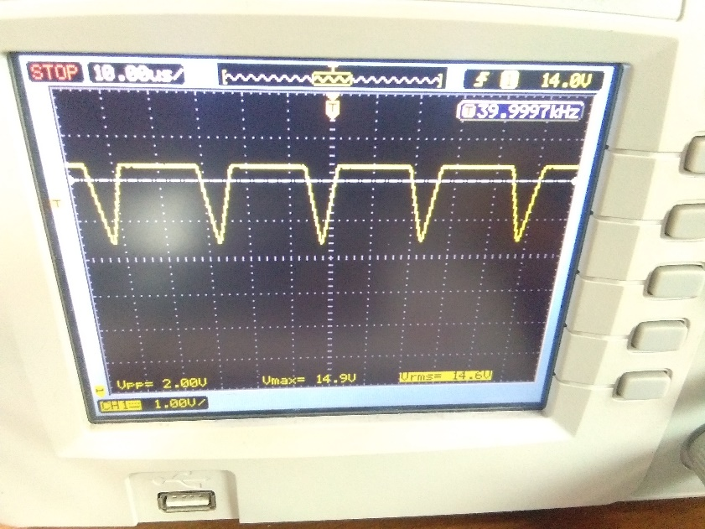

Snapshot of DSO screen with waveforms across op amp output

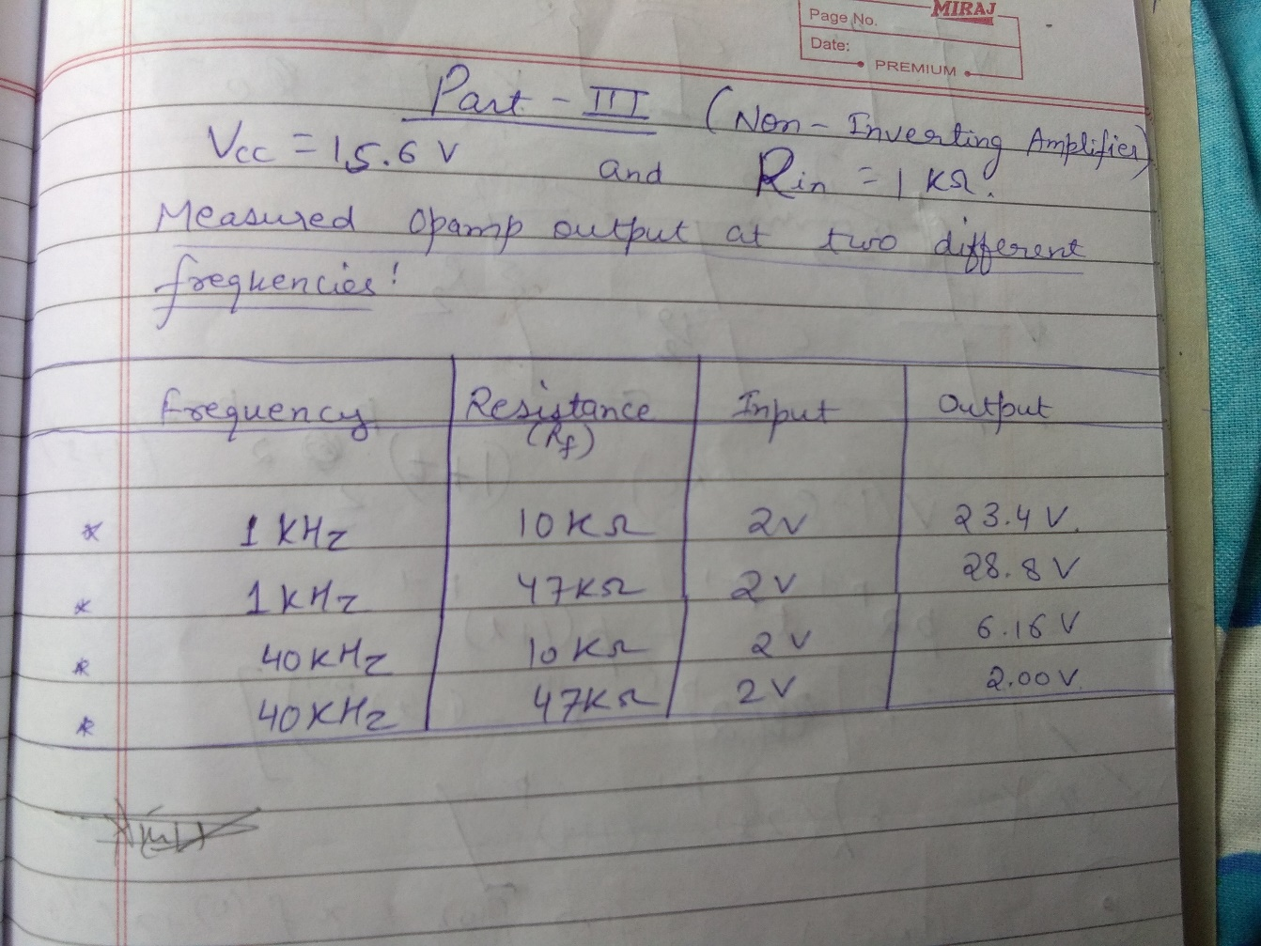

measured op amp output at two different frequencies

**Conclusion:** In this experiment we studied different op-amp circuits and by varying the setup and frequency, resistance, etc. we established different

op amp circuits (namely voltage follower, inverting amplifier and non-inverting amplifier.)

First of all, we set up the voltage follower circuit where the input voltage is always equal to the output voltage irrespective of whatever we choose our input. This method is used to block the input impedances. The voltage gain in this type is 1. Then we had an inverting amplifier circuit where the output is out of phase with the input or is inverse of the input. The voltage gain in this case is -Rf/Rin. The inverting amplifier can also be used as a summing amplifier in applications like audio mixers. The inverting input forms a virtual earth, enabling several signals to be summed together. Lastly we encountered a non-inverting amplifier circuit where the output is in phase with the input and the voltage gain is given by (1+Rf/Rin). To sum up, in these circuits we learned different types of op-amps which are very important for an electrical engineer.